Alex&Co Construction

Alex &Co General Contractors  
and Custom Home Builders

Jumbotron

## Who We Are

With over 50 years of combined experience, Joel & Co. Construction has steadily grown from a modest home remodeling contractor into a large-scale commerical and residential construction business. Today, the company continues to maintain their client-first approach, and insist on bringing integrity, honesty, and transparency to every job, every time.

The company’s continued success is due in part to their commitment to practicing safe construction methods and strict compliance with all applicable laws, rules and regulations. They work closely with clients, civil and structural engineers, architects and designers with a collaborative mindset and a common goal: to deliver a successful and beautiful project.

## Our Services

Alex & Co. Construction is often recognized as one of the leading general contracting companies in Los Angeles due to superior craftsmanship and ability to understand and execute high-level aesthetic excellence that clients desire. Whether the project calls for a traditional, contemporary, or modern design, the team will oversee every phase of construction. These teams are comprised of experts who specialize in numerous types of services and construction projects:

### [**General Contracting**](https://losangelesgeneralcontractor.com/general-contractors/)

*From remodeling to building a new home from the ground up, Alex & Co. is passionate about creating a rewarding construction experience for our clients, our designers and trade partners, and our team.*

### [**Custom Home Building**](https://losangelesgeneralcontractor.com/custom-home-builder/)

*The team at Alex & Co. possess a powerful understanding of the design process, and the creativity to synthesize it with construction planning.*

### [**Kitchen Remodeling**](https://losangelesgeneralcontractor.com/kitchen-remodeling/)

*Remodeling the kitchen is a great way to give a home a facelift. Working within the client’s budget, Alex & Co. provides the best service and return on investment.*

### [**Bathroom Remodeling**](https://losangelesgeneralcontractor.com/bathroom-remodeling/)

*Alex & Co. can transform any bathroom into a desirable retreat ⁠— bringing the vision of the homeowner to life by redesigning and remodeling their old bathrooms and transforming them into a dream space.*

### [**Room Additions**](https://losangelesgeneralcontractor.com/room-additions/)

*Adding additional rooms is an important job and is best left to an experienced room addition contractor. Alex & Co. provides renditions of the general and specific areas of the home to present the best plan of action for the new addition.*

### [**Commercial Construction**](https://losangelesgeneralcontractor.com/commercial-construction)

*Whether you need to renovate a restaurant or build a new, high-end spa, Alex & Co.’s quality workmanship makes the planning and construction process simple and easy ⁠— resolving in a practical and attractive commercial space.*

## [Blog](https://losangelesgeneralcontractor.com/blog/)

[[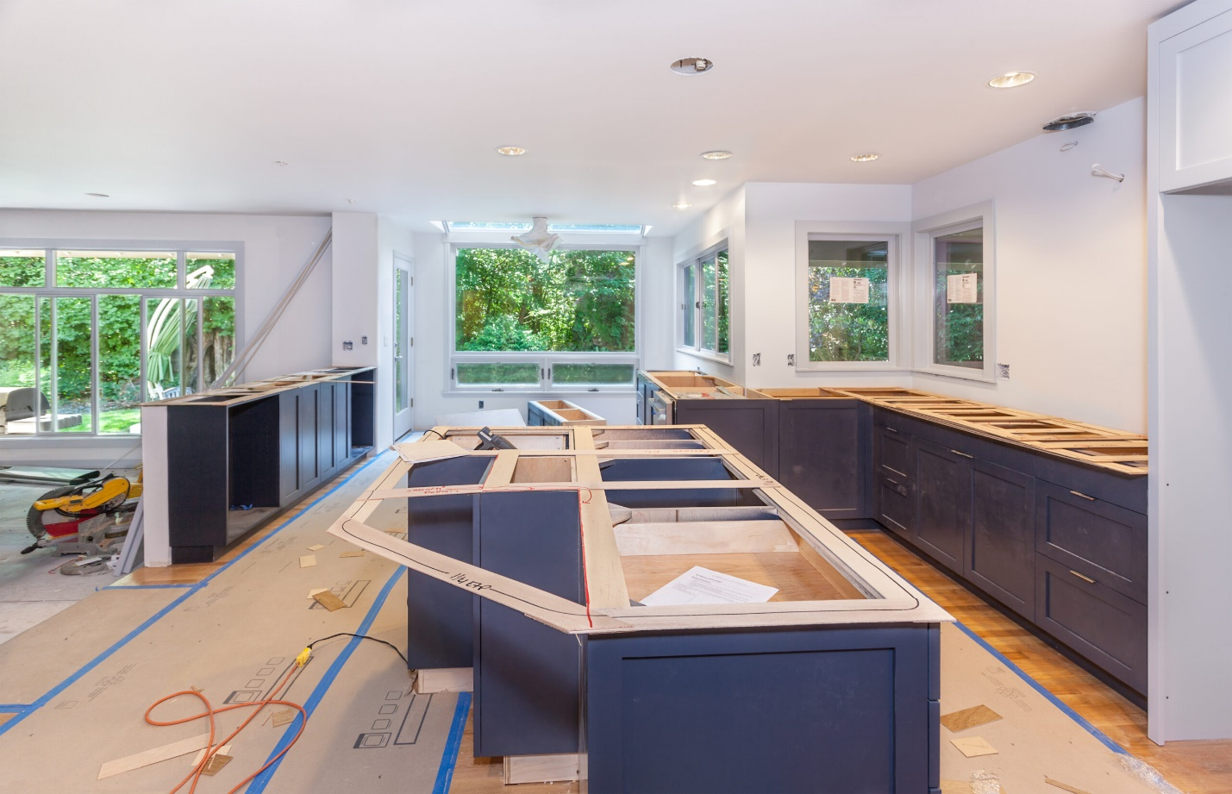](https://losangelesgeneralcontractor.com/transform-your-space-a-guide-to-kitchen-remodeling/)](https://losangelesgeneralcontractor.com/transform-your-space-a-guide-to-kitchen-remodeling/" \o "Transform Your Space: A Guide to Kitchen Remodeling)

### [**Transform Your Space: A Guide to Kitchen Remodeling**](https://losangelesgeneralcontractor.com/transform-your-space-a-guide-to-kitchen-remodeling/)

Are you tired of your outdated kitchen and craving a fresh, modern look? Kitchen remodeling might be the answer to breathe new life into your culinary haven. From enhancing functionality to boosting aesthetic appeal, a well-executed kitchen remodel can elevate the heart of your home. Here's a brief guide to help you navigate the exciting journey of transforming your kitchen. 1. Define Your Goals: Begin by identifying your goals for the remodel. Are you looking to create a more open…

[READ MORE](https://losangelesgeneralcontractor.com/transform-your-space-a-guide-to-kitchen-remodeling/)

[[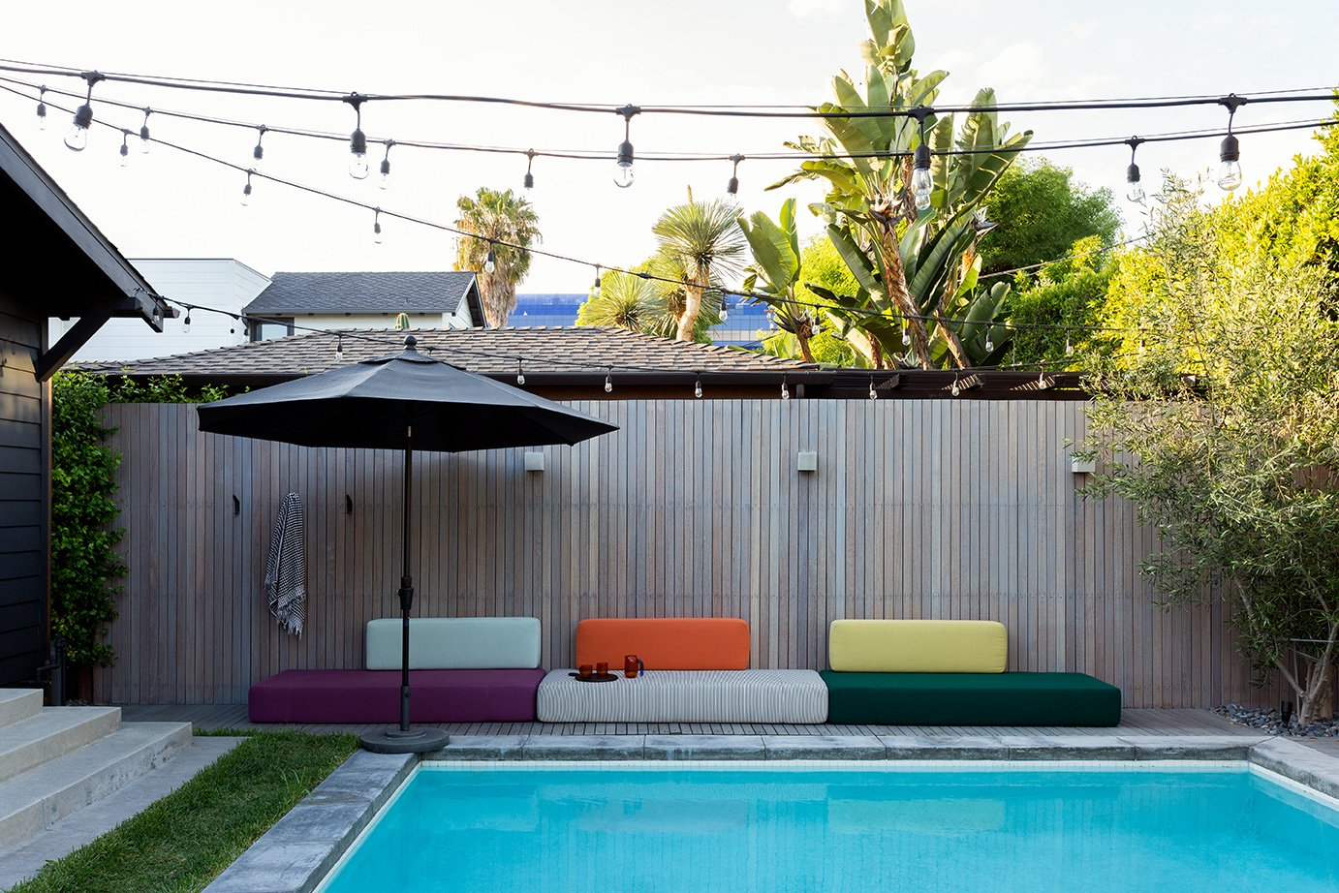](https://losangelesgeneralcontractor.com/building-a-greener-future-sustainable-homes-in-los-angeles/)](https://losangelesgeneralcontractor.com/building-a-greener-future-sustainable-homes-in-los-angeles/" \o "Building a Greener Future: Sustainable Homes in Los Angeles)

### [**Building a Greener Future: Sustainable Homes in Los Angeles**](https://losangelesgeneralcontractor.com/building-a-greener-future-sustainable-homes-in-los-angeles/)

Embracing Eco-Friendly Construction In an era where environmental sustainability is more crucial than ever, the construction industry is evolving to meet the growing demand for eco-friendly practices. At Alex & Co. Construction, a leading general contractor in Los Angeles, we are committed to pioneering sustainable home building solutions. Our approach to eco-friendly construction not only minimizes environmental impact but also enhances the living experience for homeowners in Los Angeles. Innovations in Sustainable Home Building Eco-Friendly Materials and Techniques: The cornerstone…

[READ MORE](https://losangelesgeneralcontractor.com/building-a-greener-future-sustainable-homes-in-los-angeles/)

[[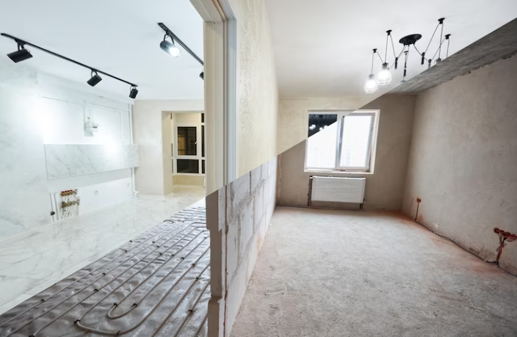](https://losangelesgeneralcontractor.com/expanding-horizons-making-room-additions-in-your-home/)](https://losangelesgeneralcontractor.com/expanding-horizons-making-room-additions-in-your-home/" \o "Expanding Horizons: Making Room Additions in Your Home)

### [**Expanding Horizons: Making Room Additions in Your Home**](https://losangelesgeneralcontractor.com/expanding-horizons-making-room-additions-in-your-home/)

Expanding your home through room additions is a practical way to enhance your living space and increase property value. Whether you need an extra bedroom, a larger kitchen, or a dedicated home office, here are some key steps to consider when making room additions in your home: Plan Carefully Begin by envisioning the purpose of the new space. Consider the layout, size, and location of the addition. Think about how the new space will integrate with the existing structure and…

[READ MORE](https://losangelesgeneralcontractor.com/expanding-horizons-making-room-additions-in-your-home/)

[[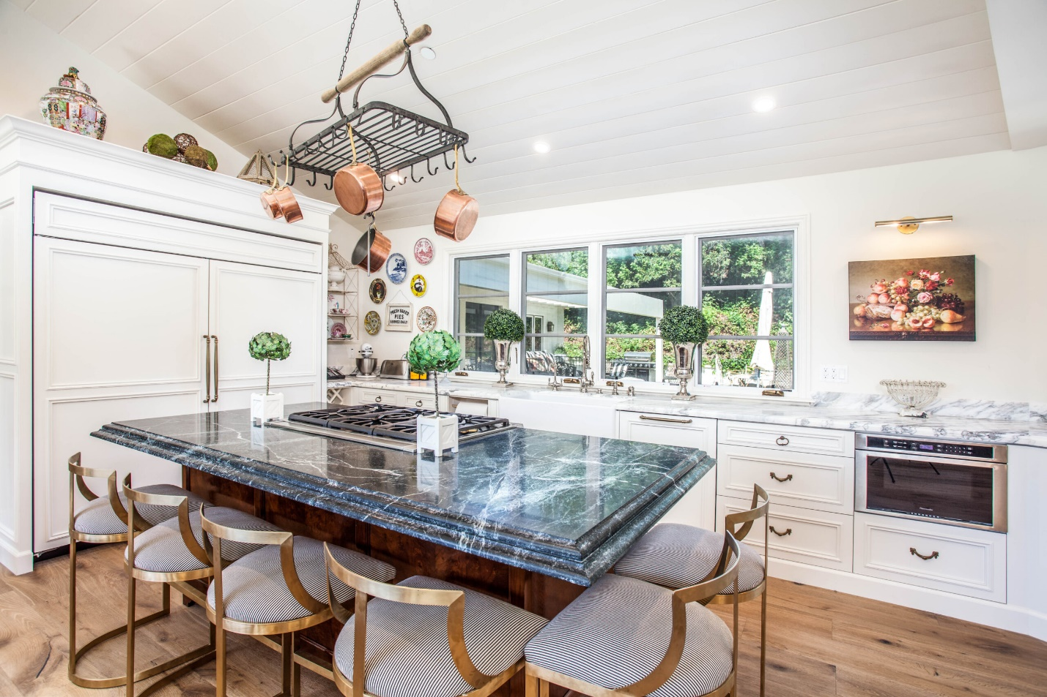](https://losangelesgeneralcontractor.com/beautiful-styles-for-your-kitchen-remodel-project/)](https://losangelesgeneralcontractor.com/beautiful-styles-for-your-kitchen-remodel-project/" \o "Beautiful Styles for Your Kitchen Remodel Project)

### [**Beautiful Styles for Your Kitchen Remodel Project**](https://losangelesgeneralcontractor.com/beautiful-styles-for-your-kitchen-remodel-project/)

When it comes to kitchen remodel projects, choosing the right style is crucial for achieving a beautiful and functional space. Whether you prefer a classic, modern, or farmhouse-inspired kitchen, here are three stunning styles to consider for your renovation project: 1. Classic Elegance Classic kitchens never go out of style. They are characterized by timeless design elements that exude elegance and sophistication. Some key features of a classic kitchen include: Cabinetry: They often feature raised-panel or shaker-style cabinets with ornate…

[READ MORE](https://losangelesgeneralcontractor.com/beautiful-styles-for-your-kitchen-remodel-project/)

[[](https://losangelesgeneralcontractor.com/5-benefits-of-custom-home-building-projects/)](https://losangelesgeneralcontractor.com/5-benefits-of-custom-home-building-projects/" \o "5 Benefits of Custom Home Building Projects)

### [**5 Benefits of Custom Home Building Projects**](https://losangelesgeneralcontractor.com/5-benefits-of-custom-home-building-projects/)

Building a home is a significant life decision, and choosing between buying an existing property or opting for a custom home building project can be a challenging choice. While pre-existing homes offer convenience, they may not always fulfill your unique vision and lifestyle needs. On the other hand, custom home building allows you to create a dream home from the ground up, tailor-made to suit your preferences and desires. In this blog, we explore the five major benefits of embarking…

[READ MORE](https://losangelesgeneralcontractor.com/5-benefits-of-custom-home-building-projects/)

[[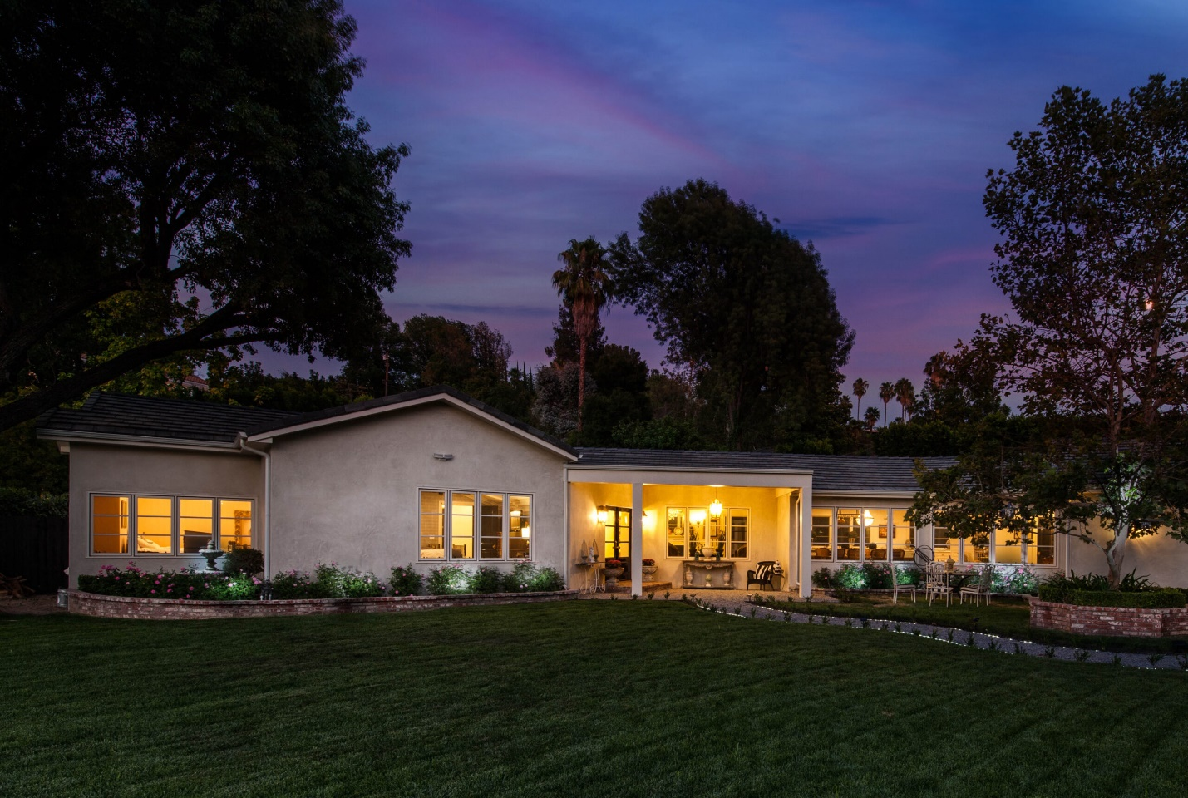](https://losangelesgeneralcontractor.com/guide-to-prepare-for-a-home-renovation-project/)](https://losangelesgeneralcontractor.com/guide-to-prepare-for-a-home-renovation-project/" \o "Guide to Prepare For a Home Renovation Project)

### [**Guide to Prepare For a Home Renovation Project**](https://losangelesgeneralcontractor.com/guide-to-prepare-for-a-home-renovation-project/)

Embarking on a home renovation project can be an exciting yet overwhelming endeavor. Whether you're planning to remodel your kitchen, renovate your bathroom, or give your entire home a makeover, proper preparation is key to ensuring a successful and stress-free renovation experience. In this guide, we will walk you through the essential steps to prepare for your project. Define Your Renovation Goals Start by clearly defining your renovation goals. What do you hope to achieve with this project? Identify the…

[READ MORE](https://losangelesgeneralcontractor.com/guide-to-prepare-for-a-home-renovation-project/)

[[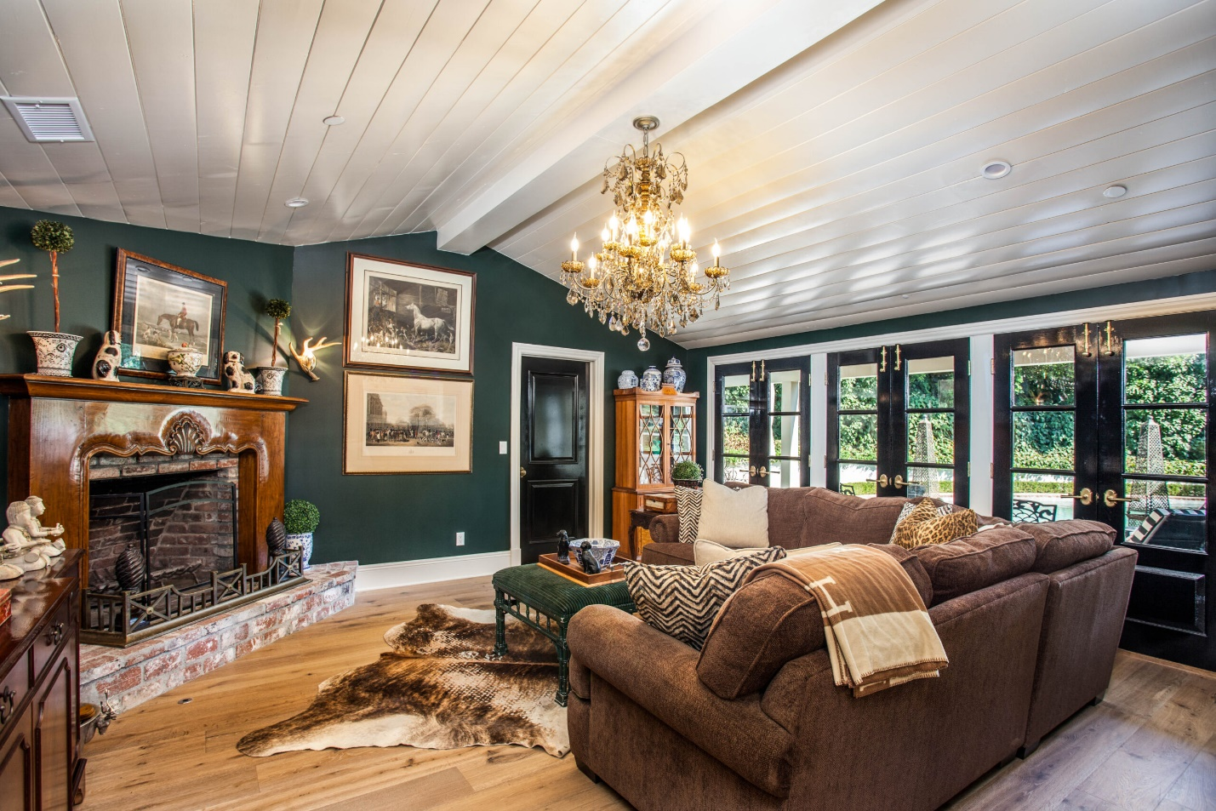](https://losangelesgeneralcontractor.com/best-luxury-roofs-for-your-living-room/)](https://losangelesgeneralcontractor.com/best-luxury-roofs-for-your-living-room/" \o "Best Luxury Ceilings For Your Living Room)

### [**Best Luxury Ceilings For Your Living Room**](https://losangelesgeneralcontractor.com/best-luxury-roofs-for-your-living-room/)

The living room is the heart of the home, a place where comfort meets style and where memories are made. When it comes to creating a luxurious and captivating living room, the design of the ceiling plays a pivotal role. A well-designed and meticulously crafted ceiling can transform an ordinary living room into a breathtaking space that exudes elegance and sophistication. In this blog post, we will explore some of the best luxury ceilings for your living room, showcasing exquisite…

[READ MORE](https://losangelesgeneralcontractor.com/best-luxury-roofs-for-your-living-room/)

[[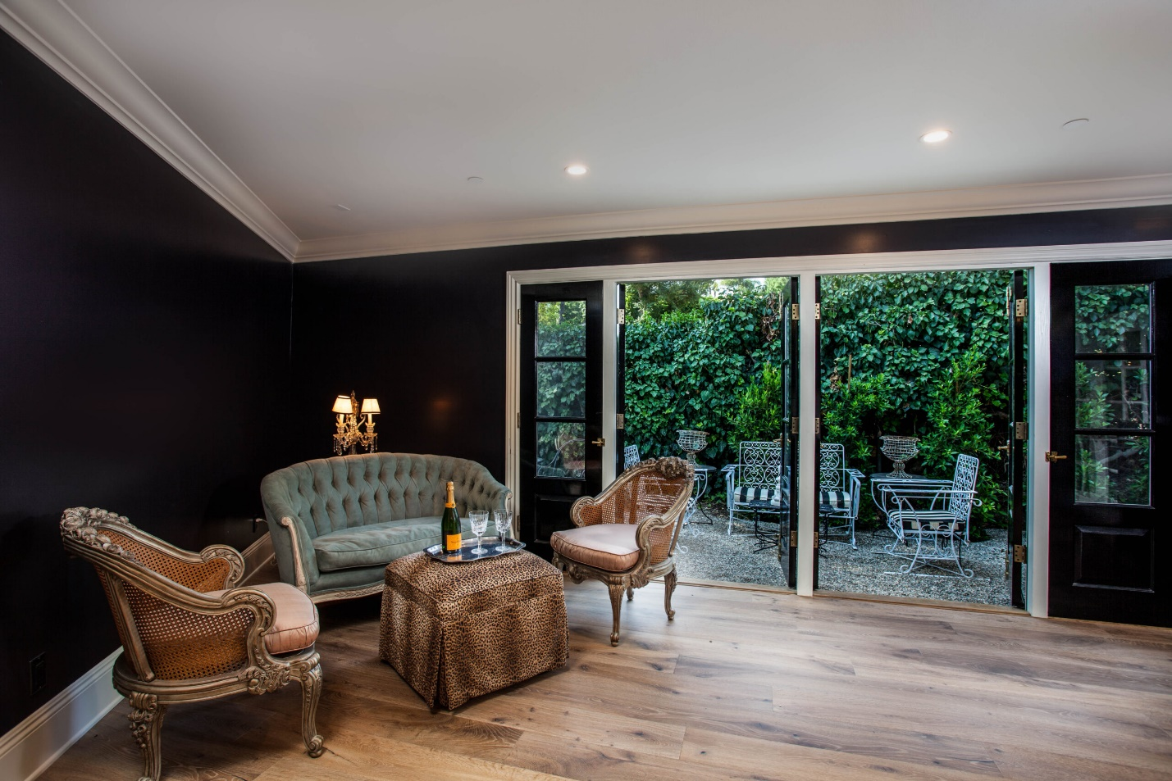](https://losangelesgeneralcontractor.com/vintage-styles-you-will-want-for-your-remodeling-project/)](https://losangelesgeneralcontractor.com/vintage-styles-you-will-want-for-your-remodeling-project/" \o "Vintage Styles For Your Remodeling Project)

### [**Vintage Styles For Your Remodeling Project**](https://losangelesgeneralcontractor.com/vintage-styles-you-will-want-for-your-remodeling-project/)

Vintage styles have been popular in interior design for many years and continue to be a sought-after look for homeowners. If you're planning a remodeling project and want to incorporate vintage elements, there are many styles to choose from. In this blog, we'll explore some styles that are sure to add character and charm to your home. Mid-Century Modern A vintage style that originated in the 1950s and 60s. This style is characterized by clean lines, geometric shapes, and a…

[READ MORE](https://losangelesgeneralcontractor.com/vintage-styles-you-will-want-for-your-remodeling-project/)